Contact: Rick Scott 310.306.0375
rick@greatscottpr.com

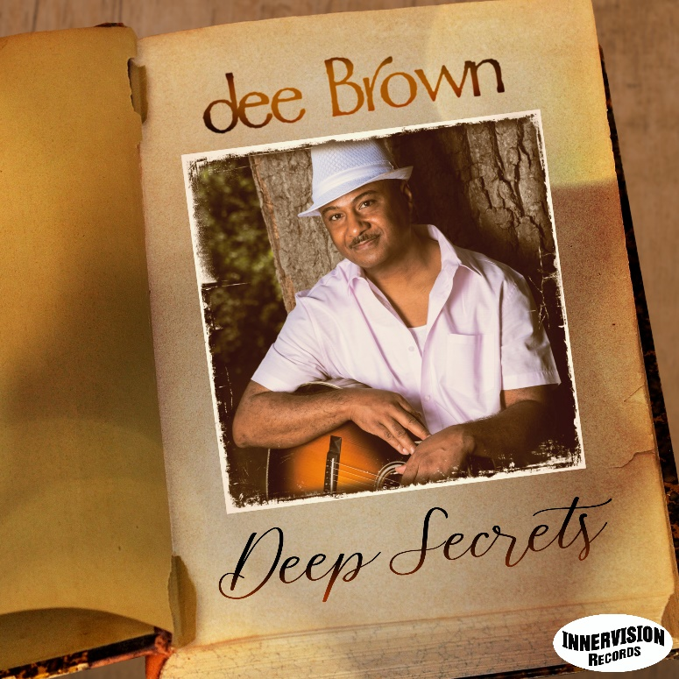

Groove jazz guitarist dee Brown to reveal
“Deep Secrets” on September 3

The album drops a few days before the single “Tie The Knot” featuring Lin Rountree goes for playlist adds.

DETROIT (XX August 2021): That’s the good book on the cover of groove jazz guitarist dee Brown’s forthcoming album, not a tantalizing spy novel titled “Deep Secrets.” But like a thrilling page turner, Brown delves into mystery on his fifth album that drops September 3 on Innervision Records. He ponders God’s mysteries on the collection of R&B, jazz, soul and gospel songs that he wrote and produced with GRAMMY nominated producer Valdez Brantley with production and mixing assistance from Billboard chart-topper Blake Aaron, multiple GRAMMY nominee Darren Rahn and Nate Harasim.

“No eye has seen, no ear has heard, and no mind has imagined what God has prepared for those who love him. But it was to us that God revealed these things by his Spirit. For his Spirit searches out everything and shows us God’s deep secrets,” said Brown quoting from the book of Corinthians to share his inspiration for the album.

The Detroit-area native began writing music for the new set a couple of years ago and after losing his mother to whom the album is dedicated, he turned to his faith for inspiration. When COVID-19 hit accompanied by quarantine and restrictions, Brown’s recording process had to shift into remote mode with the musicians recording their tracks in their home studios and emailing them to Brown and Brantley (piano, keyboards, strings and programming). With Brown’s electric guitar seemingly issuing lyrical admonitions, the first single, “Smooth Talk,” hit the Billboard top 30 last fall. He again quotes scripture to reveal the song’s origins.

“The song has to do with people who try to convince you to do things you don’t really want to do. Romans 16 says, ‘Such people are not serving Christ our Lord; they are serving their own personal interests. By smooth talk and glowing words, they deceive innocent people,’” said Brown about the cut that fades with a soul-powered saxophone solo by Michael Parlett.

The next album preview came a few months later when the feel-good groove “The Prize” was released for airplay. Sunny and sublime, it’s another tune that has spiritual roots.

“The prize is what we are all striving for. To paraphrase Corinthians, ‘Don’t you realize that in a race everyone runs, but only one person gets the prize? We do it for an eternal prize. I run with purpose in every step,” said Brown.

Bassist Darryl Williams and drummer Tony Moore carve a deep, tight groove on “Love You Too,” released last March as a single, garnering over 100,000 YouTube views. And now comes “Tie The Knot,” the fourth single from “Deep Secrets,” which goes for playlist adds on September 6. Soul trumpeter Lin Rountree serves as a standout counterpart to Brown’s cool-toned guitar come-ons.

Brown’s subjects throughout “Deep Secrets” explore passions and habits (“Controlled Passion”), the spiritual quest (“Make Up Your Mind”), purpose (“Wake Up”), divine will (“Surrender”), and his first grandchild (“Pretty Girl (Skyler)”). William Murphy III wrote the gospel standard “Praise Is What I Do,” an epic seven-minute sermon that finds Brown’s guitar emphatically preaching from the pulpit amidst an orchestral opening, Gerard Brooks’ impassioned lead vocals, a celestial gospel choir and Merlon Devine’s soprano sax illuminations.
Brown debuted as a solo artist on 2007’s “No Time To Waste” and released his first album for Innervision Records, “Brown Sugar Honey-Coated Love,” seven years ago. His singles have consistently found their way onto the charts over the years. In concert settings, the guitarist has performed or shared the stage with legends, hitmakers and award winners - from Aretha Franklin, Al Jarreau, Jeffrey Osborne, BeBe Winans and Ohio Players to Bob James, Spyro Gyra, Gerald Albright, Brian Culbertson, Najee, Paul Taylor, Paul Brown, Mindi Abair and Alexander Zonjic, among others.
“Deep Secrets” contains the following songs:

“Love You Too”
“Smooth Talk”
“The Prize”
“Surrender”
“Make Up Your Mind”
“Wake Up”
“Praise Is What I Do”
“Deep Secrets”
“Controlled Passion”
“Tie The Knot”
“Pretty Girl (Skyler)”

For more information, please visit https://www.deebrownmusic.com.
# # #

